Template for Evidence(s)
UI GreenMetric Questionnaire

College : BULACAN AGRICULTURAL STATE COLLEGE
Country : PHILIPPINES
Web Address : info@basc.edu.ph

[2] Energy and Climate Change (EC)
SAMPLE

[2.13] Number of innovative program(s) in energy and climate change

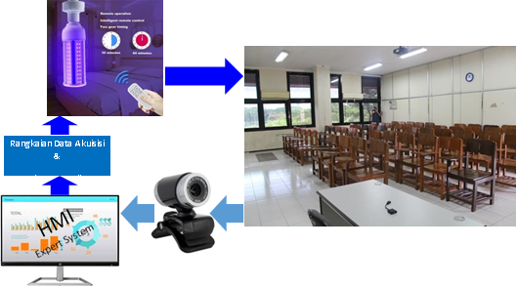
Smart room sterilization system using UVC rays
Examples of innovative program (Institut Teknologi Sepuluh Nopember, Indonesia)

Description:
(Please describe innovative program(s) on your campus. The following is an example of the description. You can describe more related items if needed.)

UVC is used to maintain air quality standards despite the dynamics of cooling load and the dynamics of biological pollutants in the room. There are also innovations in room sterilization using UVC rays for biological pollutants attached to the surfaces such as benches, floors, and walls. Irradiating of rooms is carried out automatically every time the room is about to be used or after an activity and can be automated via condition sensors attached to PC-operated web cams.

The irradiation process is carried out at certain time intervals when the room unoccupied. During the process the door is closed and information is displayed to users outside. UVC wavelengths can be remotely regulated so they can be used for multi-organic sterilization of pollutants (biological pollutants).

Additional evidence link (i.e., for videos, more images, or other files that are not included in this file):

