Template for Evidence(s)
UI GreenMetric Questionnaire

College : BULACAN AGRICULTURAL STATE COLLEGE
Country : PHILIPPINES
Web Address : info@basc.edu.ph

[2] Energy and Climate Change (EC)
SAMPLE
[2.6] Electricity Usage per Year (in Kilowatt hour)

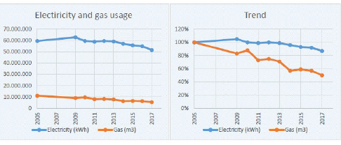
Example of Total Electricity and Gas Usage (All Locations) in 2005-2017 (Wageningen University & Research, Netherlands)
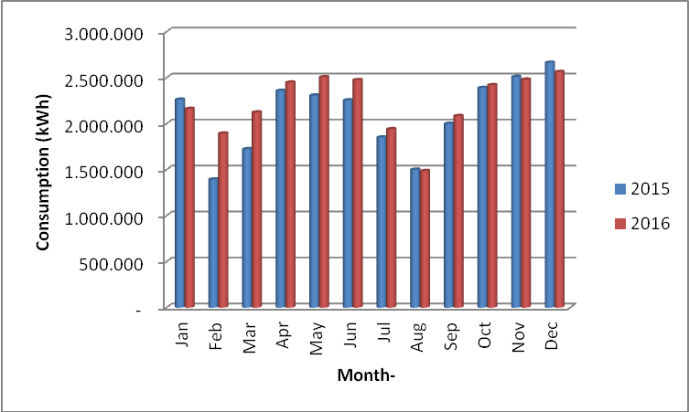
Example of Electricity Usage (kWh) on UI Depok Campus (Universitas Indonesia, Indonesia)

Description:
(Please describe the electricity usage per year on your campus. The following is an example of the description. You can describe more related items if needed.)

The total electricity usage of Wageningen Campus in 2017 is 40.228.415 kWh. On the main campus area of Wageningen University & Research in Wageningen electricity is used for lighting, cooling, heating and laboratory appliances. For more information see the Energy paragraph of the WUR 2017 Annual environmental report.

Additional evidence link (i.e., for videos, more images, or other files that are not included in this file):

