Template for Evidence(s)
UI GreenMetric Questionnaire

College : BULACAN AGRICULTURAL STATE COLLEGE
Country : PHILIPPINES
Web Address : info@basc.edu.ph
SAMPLE
[2] Energy and Climate Change (EC)

[2.9] Elements of Green Building Implementation as Reflected in All Construction and Renovation Policies


Example of Green Building Implementation - Copy of the DCU ISO50001 certification (Dublin City University, Ireland )
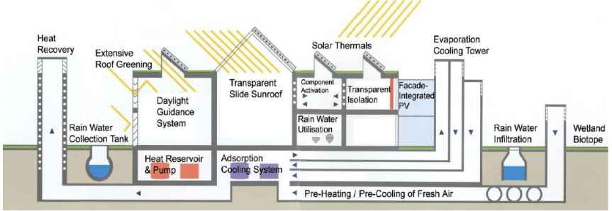
Example of Green Building Implementation - Overview Green Technologies implemented at the Environmental Campus Birkenfeld (Umwelt-Campus Birkenfeld, Germany)

Description:
(Please describe the elements of green building implementation on your campus. The following is an example of the description. You can describe more related items if needed.)

- Dublin City University gained ISO 50001 certification – also attached is DCU’s construction and renovation policy.
All buildings of the Environmental Campus Birkenfeld fulfil the requirements of the European and German Energy Standards for Buildings, whereby some reach much higher standards. ECB implemented the elements of ‘green building’ such as an adsorption cooling plant for cooling purposes, a geothermal heat exchanger to pre-warm the outside air, a solar heat transmitter with heat storage capacity to provide heat, a solar thermal collector as heat source for a compression heat pump, a district heating system supplied by a wood-fired power station, two compression heat pumps, a rainwater cistern with a pressure regulator, two ventilation pumps fitted with high-performance waste-heat extractors.

Additional evidence link (i.e., for videos, more images, or other files that are not included in this file):

