Template for Evidence(s)
UI GreenMetric Questionnaire

College : BULACAN AGRICULTURAL STATE COLLEGE
Country : PHILIPPINES
Web Address : info@basc.edu.ph

[3] Waste (WS)
SAMPLE
[3.6] Sewage Disposal

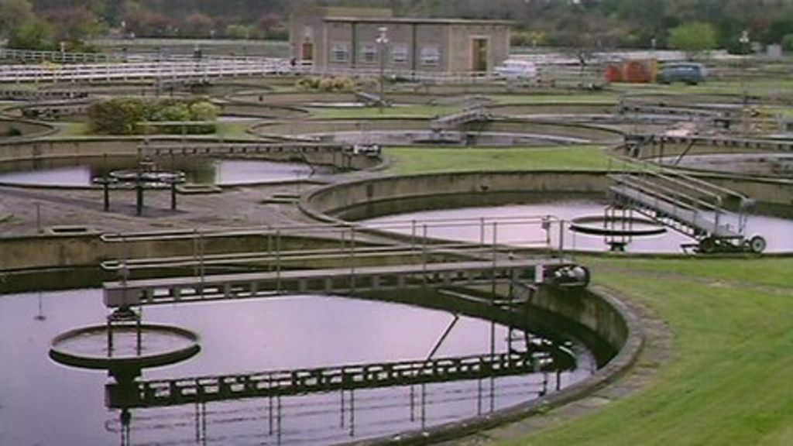
Example of Sewage Disposal (Nottingham Trent University, UK)

Description:
(Please describe the sewage disposal on your campus. The following is an example of the description. You can describe more related items if needed.)

Sewerage undertakers in the UK have a duty under the Water Industry Act 1991 to provide, improve and extend a system of public sewers (for both domestic and trade flows). They have a duty to cleanse and maintain those sewers (and any lateral drain) to ensure that the area that they serve is effectively drained. There is also a duty to make provision for the emptying of those sewers, normally through sewage treatment works, or where appropriate, through discharges direct to watercourses. Severn Trent Water Plc are the providers of this service to NTU sewerage disposal for all campuses.

Additional evidence link (i.e., for videos, more images, or other files that are not included in this file):

