Template for Evidence(s)
UI GreenMetric Questionnaire
College : BULACAN AGRICULTURAL STATE COLLEGE
Country : PHILIPPINES
Web Address : info@basc.edu.ph

[3] Waste (WS)
SAMPLE
[3.4] Inorganic Waste Treatment

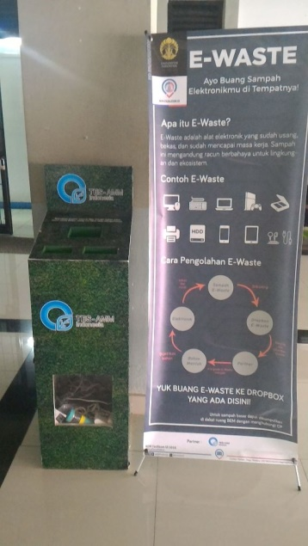
Example of Inorganic Waste Treatment (Universitas Indonesia, Indonesia)
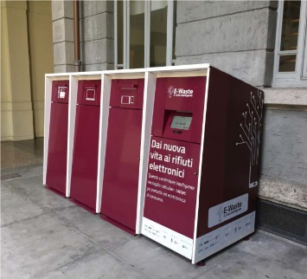 | 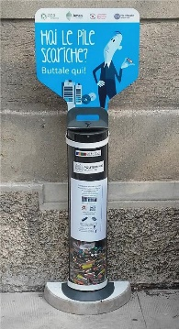
Example of Inorganic Waste Treatment (Politecnico di Milano, Italy)

Description:
(Please describe the program to treat inorganic waste on your campus. The following is an example of the description. You can describe more related items if needed.)

- Inorganic Waste treatment in Politecnico di Milano developed with AMSA (Milan Environmental Services Company) together with others companies, had foreseen the installation of an inorganic waste collector in which WEEE (Waste Electrical and Electronic Equipment) could be gathered. The main scope of the project was to optimize, and generally improve, the recycle process of small WEEEs in order to recover valuable precious metals and rare earth elements, through a low impact pilot-project.
- Battery Project: the project, starts from the collaboration between the University, the Municipality of Milan and AMSA, has the aim to raise users and citizen awareness on WEEEs collection and recycling.

Additional evidence link (i.e., for videos, more images, or other files that are not included in this file):

