Template for Evidence(s)
UI GreenMetric Questionnaire

College : BULACAN AGRICULTURAL STATE COLLEGE
Country : PHILIPPINES
Web Address : info@basc.edu.ph
SAMPLE
[4] Water (WR)

[4.5] Water pollution control in campus area
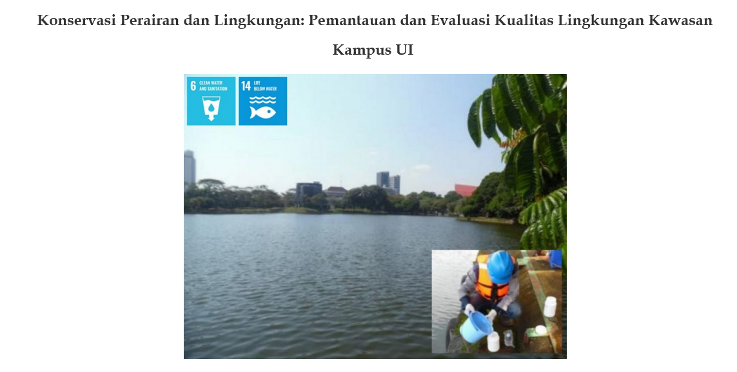
Water quality sampling and monitoring at Kenanga Lake Universitas Indonesia

Description:
(Please describe water pollution control in campus area. The following is an example of the description. You can describe more related items if needed.)

Policy
Universitas Indonesia has a policy on preventing and reducing marine pollution of all kinds, in particular from land-based activities. For example, Lake and the urban forest is maintained by Universitas.
Indonesia together with the Provincial Government of DKI Jakarta. in Decree Letter Number 3487 of 1999, this management includes joint management of the lake (reservoir) ecosystem at UI. The form of management is by maintaining the biotic and abiotic quality of the lake ecosystem through various activities, including routine monitoring and research related to lake quality at UI.
UI Rector Decree Number: 2446 / SK / R / UI / 2016 on the Master Plan of the Universitas Indonesia located in Depok 2016-2026 explains again the policy of waste management containing hazardous and toxic materials on the Universitas Indonesia campus refer to UI Rector Decree Number: 1305 / SK / R / UI / 2011 on waste and waste management containing hazardous and toxic materials. In addition, Rector of Universitas Indonesia provide some policies to support water system pollution such as:
- Rector Decree Letter Number 1308 about the policy of decreasing paper and plastic use
- Rector Decree Letter Number 4 of 2019 about Zero Plastic program
Wastewater Treatment
Universitas Indonesia has a system to prevent polluted water to enter the water system by using waste water management and microfilter.
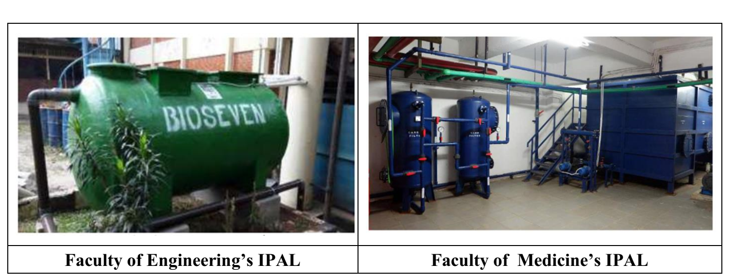
Universitas Indonesia has a waste water treatment. UI recycled its domestic wastewater to be ready to use by utilizing the domestic wastewater treatment plant or IPAL (Instalasi Pengolahan Air Limbah). The recycled water is streamed to infiltration wells, which then can be used as reserved water resources. It can reserve water with the capacity of 5 m3/day, and the IPAL output water is streamed to infiltration wells and can be used to water grass (Up-Cycling)

Guideline standard
University of Indonesia (UI) has water quality standards and guidelines for water discharges (to uphold water quality in order to protect ecosystems, wildlife, and human health and welfare). UI complies with Government Regulation Number 82 of 2001 concerning Management of Water Quality and Control of Water Pollution which contains water quality standards and guidelines for water discharges. Water quality standards can be found in the appendix and water disposal guidelines are in chapter 6 (Chapter VI).
http://www.kelair.bppt.go.id/Publikasi/BukuAirLimbahDomestikDKI/LAMP2.pdf
Monitoring and Evaluation
Universitas Indonesia have Environmental Evaluation Document and have permission from environmental agency from Government to monitoring water condition in Universitas Indonesia. Monitoring and evaluation reports done regularly every 6 months.
Additional evidence link (i.e., for videos, more images, or other files that are not included in this file):
https://k3l.ui.ac.id/konservasi-perairan-dan-lingkungan-pemantauan-dan-evaluasi-kualitas-lingkungan-kawasan-kampus-ui/

.

